Cyber Security Analysis on Internet Banking
Name
Institutional affiliation

Cyber Security Analysis on Internet Banking
In today’s society, everyone is busy either in their businesses or at their workplaces. Manual banking has been a thing of the past with many people preferring using internet banking as it is fast and is one of the easiest banking methods. Besides, no one wants to make long queues in the banks waiting to deposit or withdraw their money, hence, prefer online banking. However, as online money gets on the rise with more banking, shopping and other services, the more cyber security risks become common.
To begin with, it is essential to note the various types of cyber security attacks such as phishing attacks, malware attacks, SQL Injection Attacks (SQLi), Denial of Service attacks; Cross Site Scripting attacks (XSS), Spear Phishing Attacks, and Man in the Middle (MITM) Attacks among others as (Singer & Friedman, 2014) outlines. Singer and Friedman define cyber security threat as a possible risk that which can exploit vulnerability in a bid to breach security thereby causing possible harm.
Although it may seem like clients have larger benefits from the online banking, banks also have managed to cut costs at a higher percentage as well as improved on the customer’s experience on banking. Banks have adopted technology that is user encrypted hence managed to lure more clients into accepting the technology.
Well, it is crucial to note that the banking sectors as well as the financial sectors are more prone to security attacks as compared to other informal sectors. However, user acceptance to using these technologies or facilities is a major factor to the banks adopting online technology. Hence, as Alghazo, Kazimi, & Latif states, a certain level of information technology literacy is needed for the users to understand and comply to the banks policies (Alghazo, Kazimi, & Latif, 2017). For instance, it is a client’s duty or obligation to ensure their personal information is not shared to a third party and that their passwords, pin or email details are not easily guessed by others.
To elaborate further, the use of info graphic helps analyze graphically the cyber security threats and how to stay safe. The following info graphic shows the financial cyber threat- a map of online banking as experienced by the majority of online users who shop or bank online. In addition, the info graphic is designed to help the users navigate through and understand the internet security risks that are likely to be experienced (Kaspersky, 2019).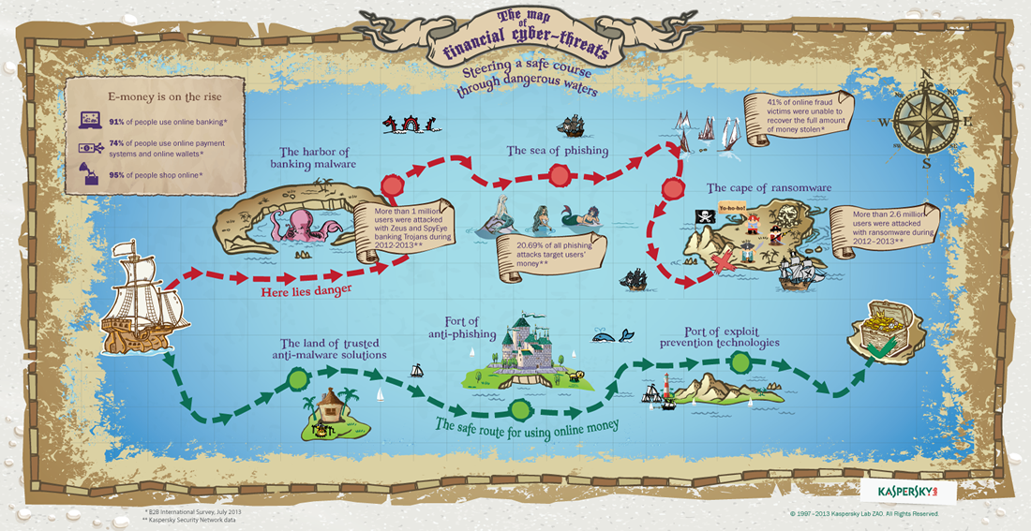
Figure 1: Info graphic: Online Banking and Shopping Cyber Threat Map.

Imminent Threats to Customer Personal Information
According to the above info graphic statistics, at least 95% of people shop online while another 91% uses online banking and 74% of the people uses online payment systems and online wallet (Kaspersky, 2019). Therefore, some of the imminent threats that a person may experience results from one of them or all through sharing of personal information online. For instance, when shopping online a catchy advert may suddenly pop up and requests you to fill in some personal details for you to receive a bonus or get the product at a discounted price. Since, the offer is too enticing, you fill in your personal details expecting to get a discount or a bonus but unfortunately that does not happen or if it does you will have traded your personal details which the hacker may use to access your banks or wallet.
Similarly, phishing attacks are more prevalent over the years where hackers trick more people using emails purported to be from banks or company emails. Often, people are lured into thinking the emails are legitimate since they are from the banks or from their workplaces yet the fraudsters create a similar email which they use to trick many people. The emails often have links that directs one to another webpage that also looks genuine where the frauds will request for bank account and credit card information or other sensitive personal details (III & Kemp, 2019). Since the websites are created for fraud purposes, they spread malware which gains access to your personal information.
According to Moore, typo squatting is another method used by cyber criminals to phish for details. In this cyber threat method, the criminals create fake websites that looks exactly as the real one with a slight difference that one may hardly notice (Moore, 2016). For instance, they secure URLs that looks like the real one but with a slight typo error from the legitimate sites. On opening, the website design is of the original where without hesitation you fill in your personal details. The website then distributes malware where they steal your personal and financial details.
Other cyber crimes and threats that may involve personal information being hacked may include Ransomware Attacks whereby the hackers gain access to your personal computer; they encrypt your files and then demand for a ransom for them to return the files back. Occasionally, the ransomware attacks aims at individual computers and users. Nevertheless, they are also capable of infecting hundreds of other computers. For example, the Municipal Transport Agency in San Francisco had about 2000 systems locked in ransomwar.
On the other hand, hackers may also pose a threat to personal information since they break into a person’s network where they steal sensitive information and later use it by pretending to be that person. Such that they identify themselves with your details to steal from others especially close friends.
In this digital era, almost all devices are accessible and enabled to internet services. Unfortunately, the security measures that can protect the users from outside attacks are still not effective. Singer & Friedman postulates that the devices have default passwords despite their availability and connectivity to the internet which is risky. The IoT and DDoS hacks increase as hackers leverage the devices for their own malicious purposes (Singer & Friedman, 2014). Since the devices are internet vulnerable to their networks, it becomes an easy job for the hackers to take advantage. Again, many people often use public wifi and hotspots which make it easier for the hackers to send their malware to such devices and thereafter retrieving personal information from the phones.

How to Prevent Information from Being Stolen
Being aware of the cyber security threats keeps one ahead of the game by ensuring that one is protected and secure against threats. To avoid phishing threats it is important for one to be cautious at all times when typing in an URL and avoid typo errors. For instance, bookmarking the legitimate websites will enable you only access the right website. As such, when inputting financial and personal details online it is necessary to countercheck the service one is applying and or the products or services purchased. Using an antivirus such as an anti-phishing protection will also reduce chances of phishing.
Hackers always are a pain and it is hard to convince your colleagues you did not defraud them especially if they got beforehand. Therefore, to avoid being hacked, ensure you regularly update your applications as well as the operating software to the latest security patches. Never share passwords or hints with third party users and this will ensure you are always fully protected from hackers (FirstTrustBank, 2018).
Most importantly, backing up files with a high quality back-up solution keeps your personal information and data protected and secure. Furthermore, the files will easily be accessible and safe regardless of situations. Exercising extreme caution when purchasing items online or when banking and ensuring you do not click on links sent to your devices is one of the best ways to play safe from cyber threats. In addition, if using a public wifi, it is necessary to use a VPN in order to have a secured connection.
Policies and Solutions to Cyber security Threats
Financial institutions and online transaction platforms need to reinforce their corporate cyber security. As much as individuals want to protect themselves from cyber security threats, it is also the responsibility of institutions and the online transaction platforms to guarantee their customers confidence to using their services. Therefore, these platforms should focus on the client satisfaction and security especially in areas such as strategy, policy and solutions to upcoming cyber security threats.
Companies often do not understand their vulnerability to corporate cyber security attack, their critical assets value or their potential attacker’s sophistication or profile. While technology is purportedly the largest source of security risks, other sources such as sociological and psychological security aspects are also a concern. Hence, adopting a corporate cyber security strategy is their main strategic pillar in cubing threats. Information technology security must also be integrated into the most important aspects of the company’s business models (Moore, 2016).
Cybersecurity policies should also be enacted. The policies should reach the employees and ensure they are aware of how vital they are to the institutions security. The clients as well should have a copy of the policies at least read and understand the terms and policies of these financial institutions and online transaction platforms.
Finally, as policies guide the institutions should adopt and implement important cyber security solutions that improves the systems reliability.

References
Alghazo, J., Kazimi, Z., & Latif, G. (2017). (PDF) Cyber security analysis of internet banking in emerging countries: User and bank perspectives. Retrieved from https://www.researchgate.net/publication/322876607_Cyber_security_analysis_of_internet_banking_in_emerging_countries_User_and_ba0nk_perspectives
FirstTrustBank. (2018). Cyber Security. Retrieved from https://www.firstrust.com/cyber-security
III, J. J., & Kemp, R. L. (2019). Cybersecurity: Current Writings on Threats and Protection. Jefferson, NC: McFarland.
Kaspersky. (2019). Retrieved from https://usa.kaspersky.com/content/en-us/images/repository/isc/Infographic-threats-online-banking-shopping.png
Moore, M. (2016). Cybersecurity Breaches and Issues Surrounding Online Threat Protection. Hershey, PA: IGI Global.
Singer, P. W., & Friedman, A. (2014). Cybersecurity: What Everyone Needs to Know. New York, NY: Oxford University Press.

